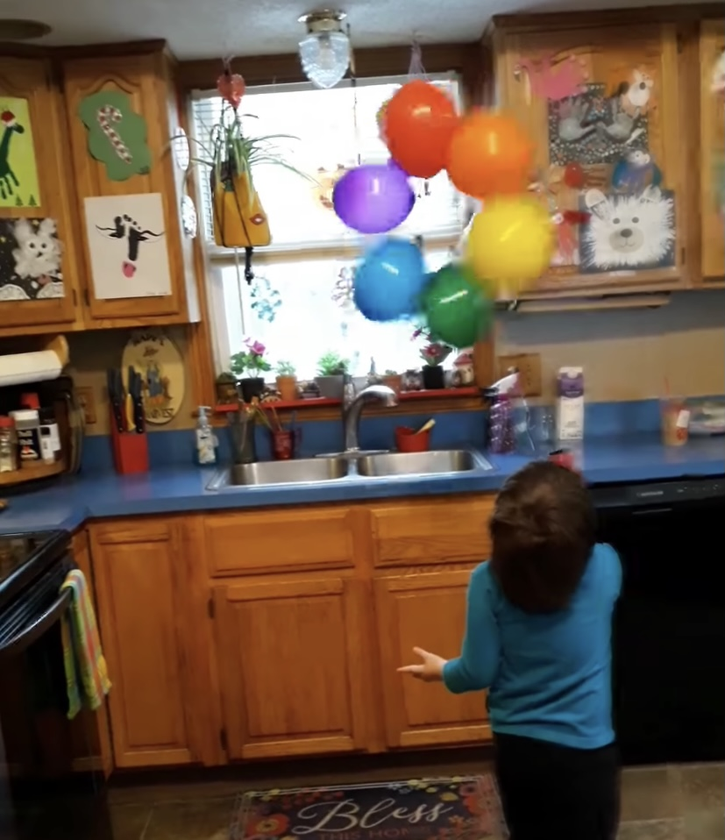

* Blow up 5 balloons
* Use cellotape to stick them together in a circle
* Use a hairdryer and see how long you can keep them moving!

Tuesday’s Challenge