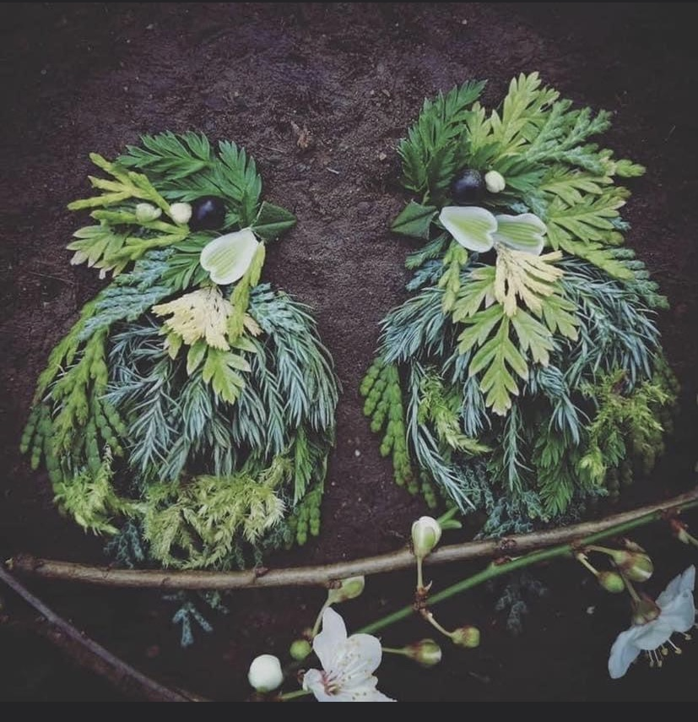

Make a picture using the leaves/twigs in your garden or gather them on a walk.

Thursday’s Challenge