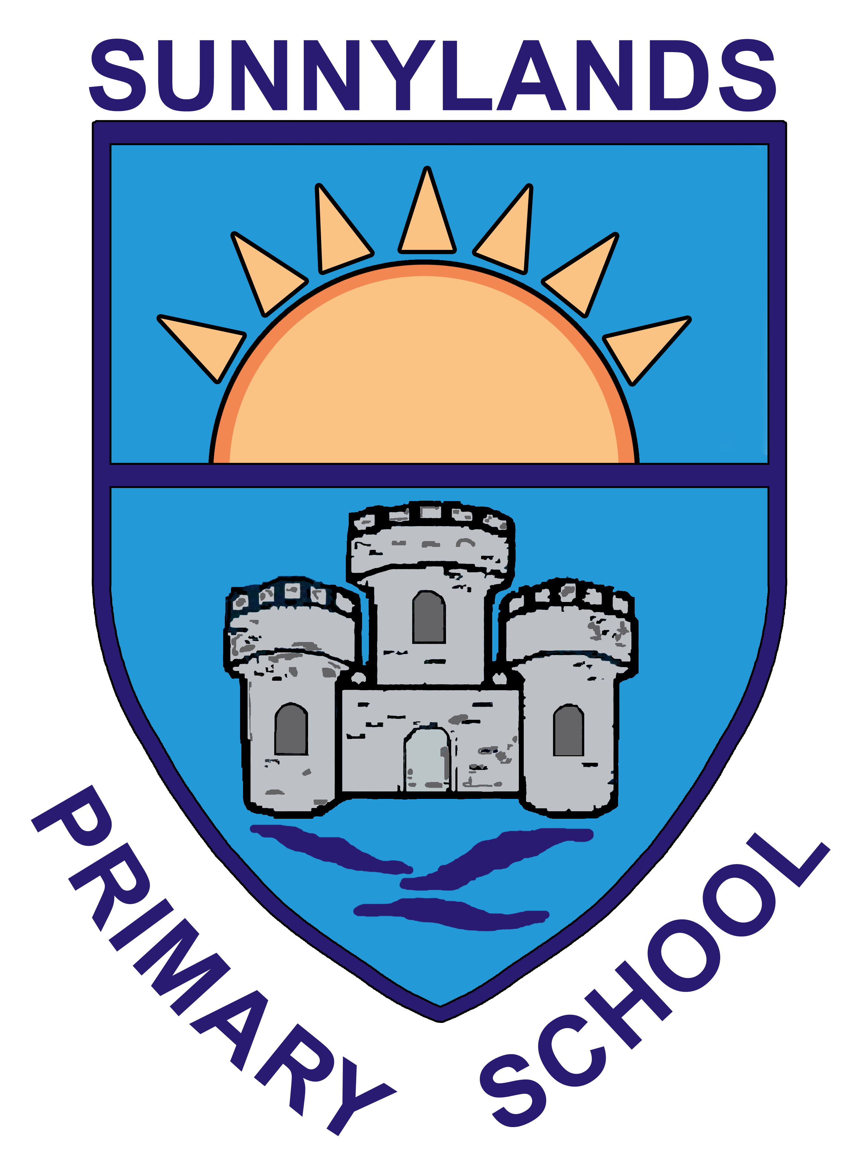

SUNNYLANDS PRIMARY SCHOOL

12th June 2020

Dear Parent/Guardian,

There has been much speculation in the media in recent days about the dates for returning to school in August/September. I have listened to the various discussions on this, I have heard the Education Minister give a date for Primary Seven to return to school, I have heard a variety of comments as to why this would not be feasible and therefore I am writing to you to give an update from Sunnylands Primary.

We, as a staff, have been working very hard to look at all our teaching and learning while our children have been learning from home. We want to say a huge thank you to you, our parents, for the tremendous effort in continuing to complete the work we have sent home and to work alongside us to help your child.

We are also working hard to have our classrooms ready for when we do start back and to think about how this might happen, depending on the restrictions that are in place.

We are not certain about the August restart date for the P7 year group or any other year group and therefore at present I am unable to give any information as to a timetable for the next academic year.

I will continue to keep parents updated with any information regarding the new school year as soon as I have concrete dates, whether that be in June or further into the traditional summer holiday period. We will also be working as a school to comply with any social distancing, hygiene and health and safety advice that we are given to ensure our children return to a safe learning environment.

We love seeing our children every day and helping them to learn, school is very empty without all the laughter and chat and I can’t wait to get to stand at the school gate and welcome everyone back as soon as possible.

I hope that you and your family keep well and that the sunshine returns soon for us all to enjoy.

Keep safe,

Mrs Lyons

